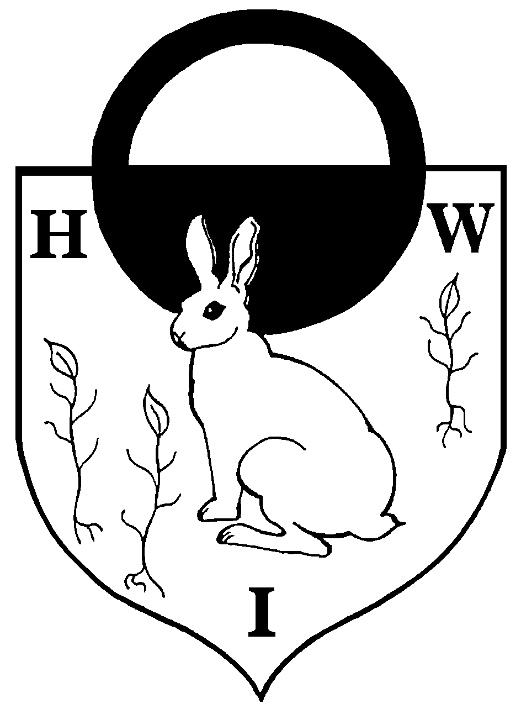  Mrs Sue Boorman B’Ed (Hons)  Headteacher  Mrs Jo Padfield BA (Hons)  Deputy Headteacher | Hatch Warren Infant School  Gershwin Road  Basingstoke  Hampshire  RG22 4PQ   01256 350313  Email: parent.mail@hwis.hants.sch.uk  Website: www.hwis.hants.sch.uk
June 2025

Dear Parents/Carers

Cool Milk

The School Food Plan's new legislation on milk came into effect on January 1st 2015. From this date schools were required to offer milk to all children aged 4-18 years.

Please go to https://www.coolmilk.com/parents/ to register your interest:

- ONLY children under 5 years old will be eligible for ‘free’ milk – as soon as your child has his/her 5th birthday you will be charged;
- If you do have any queries the website contains an email address, plus a telephone number for you to access;
- Once you have signed up to the scheme the organisers will notify the school of the names of the children who are to receive the milk;
- The school will ONLY be responsible for storing and distributing the milk – we will NOT be collecting payment or involved in any other aspect of the scheme.

Thank you
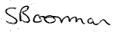
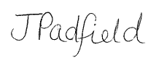

Headteacher Deputy Headteacher

