**Starting School Shopping List 2025-26**

Here is list of items your child will need when staring school in September. Please ensure that all items are **NAMED.**

School Uniform

* White polo shirt
* Grey or black trousers, skirt or dress. (Red summer dresses can also be worn)
* Red jumper or cardigan (These can have the school logo or they can be plain.)
* Black velcro trainers or school shoes (we will be outside lots so please ensure that these are sturdy.)

Items To Bring In Everyday

* 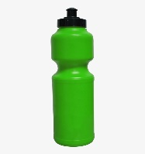A book bag (these can be bought from the office, please do NOT buy these from skoolkit as they are the wrong size and will not fit in our trays.)
* 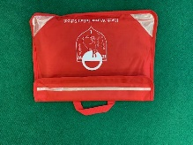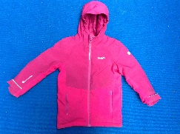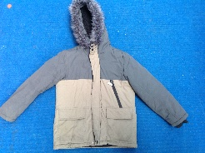A sports style water bottle.
* Waterproof and warm coat.

PE Kit-

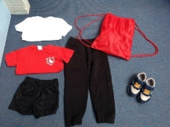We will be doing PE every Thursday. During the first half term the kits will be kept on their pegs and sent home each half term. We will then move to the children wearing their PE kits to school after Christmas. PE kits must be kept in a drawstring bag. Our pegs do NOT have room for backpacks.

* Red or white t-shirt (These can have the school logo on or they can be plain.)
* Black shorts (All children must have shorts in order to use the gymnastic equipment.)
* Dark coloured tracksuit bottoms
* Trainers (these must be velcro unless your child is able to tie their laces.)

Spare clothes

We ask that all children keep a set of old spare clothes in school in-case they need to get changed. These do NOT need to be uniform and will be kept on their pegs. These can be sent into school in a **named** carrier bag and will be sent home at the end of each half term.

* T-shirt, Jumper, Pants, Socks, Trousers
* Wellies (children will not be able to play in the STEM area or mud kitchen if they do not have a pair of wellies.)

Playdough

Every day in Year R we have dough gym. This helps to improve the children’s core strength and build their muscles ready for writing. Please can you provide your child with a standard (0.127kg) pot of Play-Doh. We have found that the best dough, that doesn’t go crumbly or sticky, is the Play-Doh brand rather than shop brands. Please send in a pot with your child’s name clearly on the lid for Monday 15th September.

Pritt stick

As you can imagine, in Year R, we explore our cutting and sticking skills most days and therefore the amount of glue we use is often extensive. To help support this we are asking for each child to provide their own labelled standard Pritt stick (Please can we ask that it is a branded **Pritt Stick** and not a shop brand as we find these work the best and last the longest). This will stay in school and the children will be able to access it whenever they need to use it. Please can this be sent to school in your child’s book bag on the first day.

Apron

In Year R we like to get messy and therefore aprons are needed to help protect our newly brought uniform. These will then follow your child throughout their time in school. These can be as simple as an old shirt but can we please ask that any apron sent in covers your child’s arms and not an overhead apron.

We understand that starting school can be an expensive time of year so please speak to the school if you have any questions.

Thank you

Year R Team