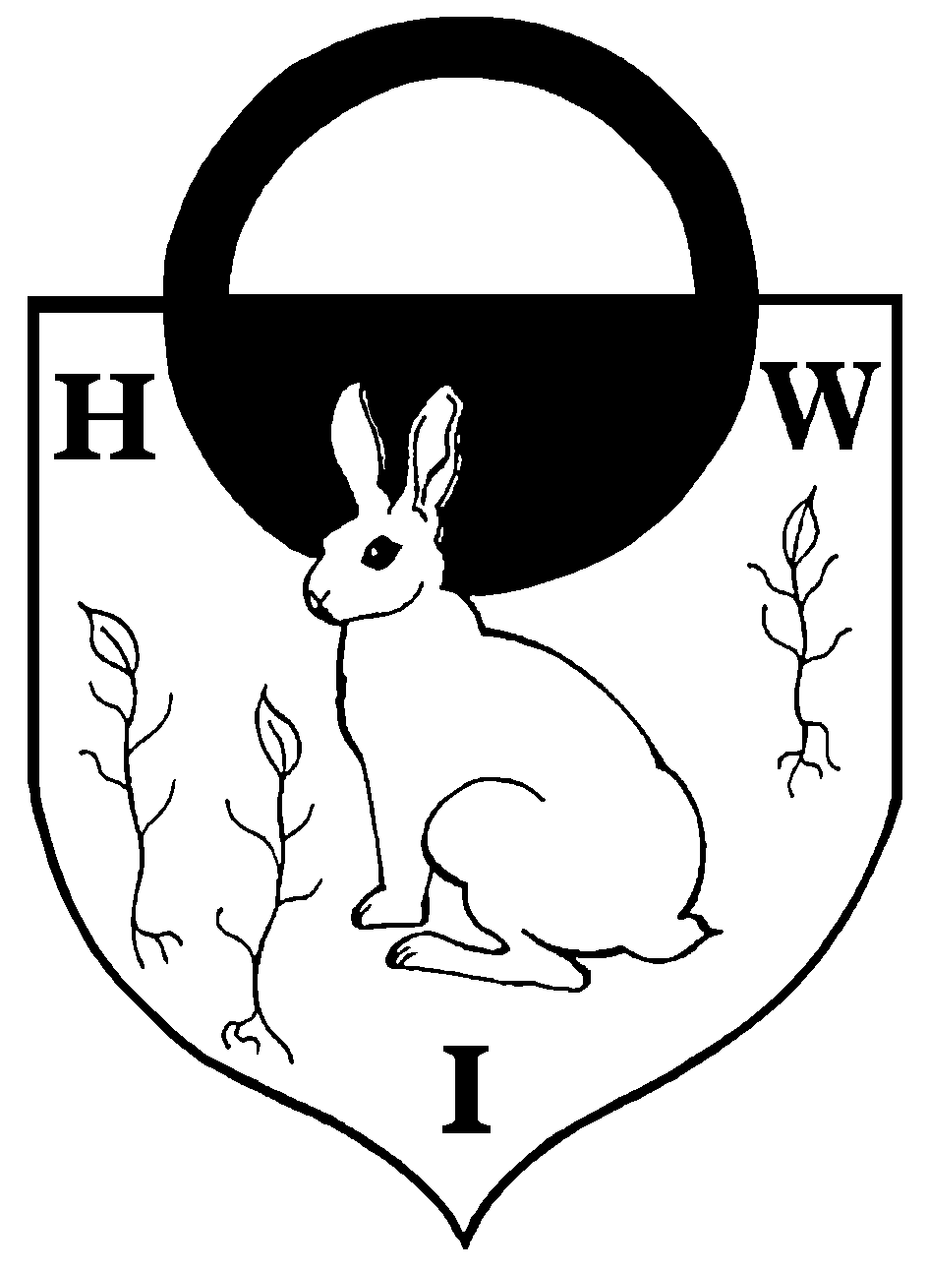  Mrs Michelle Moore BA (Hons)  Headteacher  Miss Sue Hurdle B’Ed (Hons)  Deputy Headteacher | Hatch Warren Infant School  Gershwin Road  Basingstoke  Hampshire  RG22 4PQ   01256 350313  Email: parent.mail@hwis.hants.sch.uk  Website: www.hwis.hants.sch.uk
15th November 2019
Dear Parent/Carer,
As a governing board, not only do we view it as imperative, but we have a responsibility to engage with stakeholder groups to gain valuable opinion and feedback about your child’s school. We feel you are our key stakeholders and your views are an essential part of the school’s self-evaluation and strategic planning to improve the education of pupils. We aim to maintain a culture of parental participation and engagement throughout the school, among teachers and parents alike.
A study conducted by the Department for Children, Schools and Families found that “.the involvement of parents in their school had a greater influence on attainment than family background, size of family and level of parental education….”
In previous years the feedback from parent surveys has been positive although the participation has been at a low level meaning the resulting data is of limited value and could be seen as unrepresentative. We have decided to continue with approach of giving parents the opportunity to complete the survey electronically using a trusted on-line survey provider (Microsoft Forms).
We have also split the survey up to coincide with the 3 terms of the school year making each survey quick and simple to complete. The survey is completely anonymous and cannot be traced back to any individual (unless you want to be contacted), so please be honest and fair. After we have collated the results, the governing body will use the analysed data and views to help influence its decision-making while remaining focused on the children’s needs. We will also share the results with you in an open and honest way to ensure total transparency.
Please spare us a few minutes to complete the quick survey to help us understand your feelings about the school.

Parent survey - Autumn 2019

The survey closes at midnight on the 29th November 2019. We look forward to hearing from you and thank you for sparing some of your valuable time.

Kind regards,
Board of Governors for Hatch Warren Infant School

