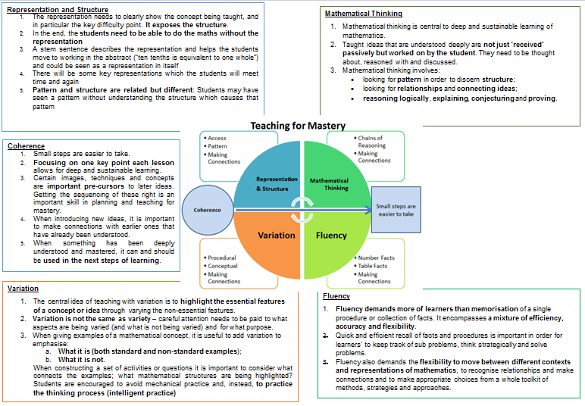

**Intent**

At Hatch Warren Infant school we want children to leave us being confident in the five main elements of Mastery: representation and structure, coherence, variation, mathematical thinking and fluency.  We want to instill confidence into our children so they can accurately and confidently answer questions and talk about their mathematics to show their understanding. We want to give children the language to confidently explain their thinking and to be creative when solving problems. This is underpinned by high expectations of all; where all children move through the curriculum at broadly the same pace; high quality modelling and reinforced ambitious vocabulary. The children are introduced to a wide variety of models, methods and equipment so they can become independent to support themselves in their own chosen way.

**Implementation**

In order to achieve this, we use the following documents to support our planning;

* **White Rose:** small step materials to help expose the structures of the mathematics to then help support children to learn and break down the maths appropriately into smaller steps.

Small Steps Autumn: <https://assets.whiteroseeducation.com/new-schemes/Year%202%20Scheme%20of%20Learning%20Small%20Steps.pdf>

Small Steps Spring: <https://assets.whiteroseeducation.com/new-schemes/Year%202%20Scheme%20of%20Learning%20Small%20Steps%20Spring.pdf>

Small Steps Summer: <https://assets.whiteroseeducation.com/new-schemes/Year%202%20Scheme%20of%20Learning%20Small%20Steps%20Summer.pdf>

* **Mastery Document**: We use the Mastery Documents to support our resources in KS1. https://www.ncetm.org.uk/media/qjpctp24/mastery_assessent_y1.pdf
* **Numberblocks:** Numberblocks are used to help support the early concepts of maths. https://www.ncetm.org.uk/media/tncbnsg3/numberblocksepisodesseries1to5.pdf
* **I See Reasoning:** we use this high-quality resource to help drip feed in reasoning examples within lessons.
* **Dip and Pick cards / Thinking Tom**:  We use these for problem solving and reasoning.

**Impact**

* Pupil voice: Pupils will be able to confidently articulate their understanding of mathematics and will talk enthusiastically about solving problems.
* Evidence in knowledge: Children will be able to make links in their learning.
* Evidence in skills: Children will be taught progressively at a pace appropriate to each individual child. Teachers subject knowledge will ensure that children’s learning is closely matched to the Early Learning Goals and National curriculum objectives with a focus on depth not breadth.
* Pupils have opportunities to experience a practical approach to Maths using a range of resources and outdoor opportunities where possible.
* Pupils enjoy Maths and show resilience when faced with a challenge.
* Pupils are engaged in their learning and make significant progress.
* Outcomes: At the end of each year we expect the children to achieve the Age Related Expectations for their year group. Some will have progressed further and reached greater depth whilst others will still be working towards. These children will receive interventions to help consolidate and plug gaps

The overview:

Year 2 – Yearly Overview

* Has number as its central concept;
* Spends large proportions of time reinforcing number to build competency;
* Ensures teachers stay in the required key stage and support the ideal of depth before breadth;
* Ensure students have the opportunity to stay together as they work through the schemes as a whole group;
* Provide plenty of time to build reasoning and problem solving elements into the curriculum.

|  |  |  |  |  |  |  |  |  |  |  |  |  |  |  |  |  |  |  |
| --- | --- | --- | --- | --- | --- | --- | --- | --- | --- | --- | --- | --- | --- | --- | --- | --- | --- | --- |
|  | Week  1 | Week  2 | Week  3 | | Week  4 | Week 5 | Week  6 | Week  7 | Week  8 | Week  9 | Week  10 | | Week  11 | Week  12 | Week  13 |  | | |
| Autumn | **Statistics** | **Number:** Place Value | | | | **Number:** Addition and Subtraction | | | | | **Geometry**: Properties of Shape | | | | | |  | | |
| Spring | **Measurement:** Money | | | **Number:** Multiplication and Division | | | | | **Number**: Fractions | | | | **Measurement**: Time | | | |  | | |
| Summer | **Number: Addition and subtraction** | | | | **Problem Solving and efficient methods** | | **Measurement:**  Length and Height | **Measurement:** Mass,  Capacity and Temperature | | | | **Investigations/ Consolidation** | | | | | |