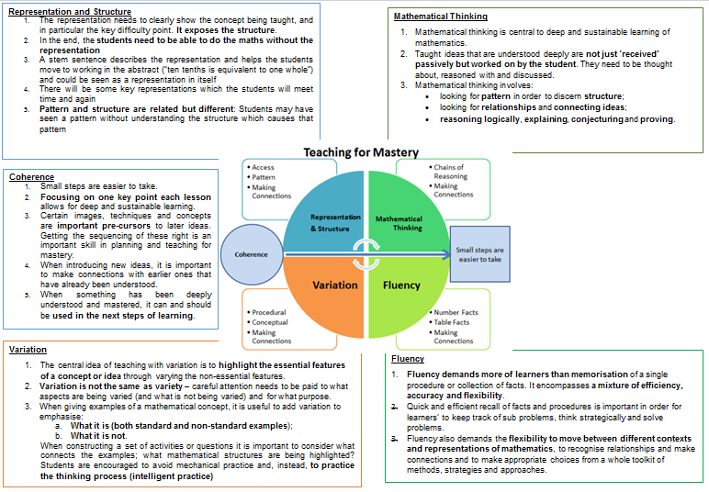**Intent**

**Intent**

At Hatch Warren Infant school we want children to leave us being confident in the five main elements of Mastery: representation and structure, coherence, variation, mathematical thinking and fluency.  We want to instill confidence into our children so they can accurately and confidently answer questions and talk about their mathematics to show their understanding. We want to give children the language to confidently explain their thinking and to be creative when solving problems. This is underpinned by high expectations of all; where all children move through the curriculum at broadly the same pace; high quality modelling and reinforced ambitious vocabulary. The children are introduced to a wide variety of models, methods and equipment so they can become independent to support themselves in their own chosen way.

**Implementation**

In order to achieve this we use the following documents to support our planning;

**White Rose Small steps** [Reception Autumn Block 1 Match sort and compare SOL.pdf (whiteroseeducation.com)](https://assets.whiteroseeducation.com/Resources/early-years/reception/autumn-block-1/Reception%20Autumn%20Block%201%20Match%20sort%20and%20compare%20SOL.pdf)

**Numberblocks:** Numberblocks are used to help support the early concepts of maths.

**I See Reasoning:** we use this high-quality resource to help drip feed in reasoning examples within lessons.

**Dip and Pick cards / Thinking Tom**:  We use these for problem solving and reasoning.

**Impact**

* Pupils enjoy Maths and show resilience when faced with a challenge.
* Pupils are able to confidently articulate their understanding of mathematics and will talk enthusiastically about solving problems.
* Pupils are able to make links in their learning.
* Pupils have opportunities to experience a practical approach to Maths using a range of resources and outdoor opportunities where possible.
* Pupils are engaged in their learning and make significant progress.

The Overview:

* Has number as its central concept;
* Spends large proportions of time reinforcing number to build competency;
* Ensures teachers stay in the required key stage and support the ideal of depth before breadth;
* Ensure students have the opportunity to stay together as they work through the schemes as a whole group;
* Provide plenty of time to build reasoning and problem solving elements into the curriculum.

**Statutory Framework:** Developing a strong grounding in number is essential so that all children develop the necessary building blocks to excel mathematically. Children should be able to count confidently, develop a deep understanding of the numbers to 10, the relationships between them and the patterns within those numbers. By providing frequent and varied opportunities to build and apply this understanding - such as using manipulatives, including small pebbles and tens frames for organising counting - children will develop a secure base of knowledge and vocabulary from which mastery of mathematics is built. In addition, it is important that the curriculum includes rich opportunities for children to develop their spatial reasoning skills across all areas of mathematics including shape, space and measures. It is important that children develop positive attitudes and interests in mathematics, look for patterns and relationships, spot connections, ‘have a go’, talk to adults and peers about what they notice and not be afraid to make mistakes.

**Mathematics ELG:** Number Children at the expected level of development will: - Have a deep understanding of number to 10, including the composition of each number; 14 - Subitise (recognise quantities without counting) up to 5; - Automatically recall (without reference to rhymes, counting or other aids) number bonds up to 5 (including subtraction facts) and some number bonds to 10, including double facts.

**ELG: Numerical Patterns** Children at the expected level of development will: - Verbally count beyond 20, recognising the pattern of the counting system; - Compare quantities up to 10 in different contexts, recognising when one quantity is greater than, less than or the same as the other quantity; - Explore and represent patterns within numbers up to 10, including evens and odds, double facts and how quantities can be distributed equally.

Daily Maths

As part of our everyday practice in EYFS we change our number on the working walls. The number is shown in a variety of ways: value, number placement, one more one less, odd and evenings, quantities, time, money, 10s frame, arras, bead string, Numicon, and number formation.

Daily Calendar: our calendar is discussed daily and shows: the days of the week, seasons, sequence daily events and events throughout the month.

|  |  |  |  |  |  |  |  |  |  |  |  |  |  |  |  |  |  |  |  |  |  |  |  |  |  |  |  |
| --- | --- | --- | --- | --- | --- | --- | --- | --- | --- | --- | --- | --- | --- | --- | --- | --- | --- | --- | --- | --- | --- | --- | --- | --- | --- | --- | --- |
|  | Week 1 | Week 2 | Week 3 | | Week 4 | | | Week 5 | Week 6 | | | Week 7 | Week 8 | | | Week 9 | | Week  10 | | | Week 11 | | Week  12 | | Week 13 | | |
| Autumn | Baseline/  Assessment | | Match and sort  Compare amounts | | | | | Talk about Measure and Patterns | | | Representing 1, 2 and 3  Comparing 1,2,3  Composition of 1,2 ,3  *NW:1 and 2*  Time – sequencing school trip | | | Circles and Triangles  *NW: 3* | | | | | Representing numbers to 5.  One more and less  *NW: 4 and 5* | | | | | Shapes with 4 sides  *NW: 6* | | Catch up/Consolidation | | |
| Spring | Alive in 5  *NW: 7* | | | Growing 7, 8, 9  *NW: 8,9, 10* | | | | | | Building 9 and 10  Length and height | | | | | | | Explore 3-D Shapes  *NW:11 and 12* | | | | | Catch up/Consolidation  *NW: 13* | | | | |
| Summer | To 20 and beyond  *NW: 14, 15 16* | | | | | How Many Now?  *NW:17* | Manipulate, compose and decompose  *NW:18* | | | | | Sharing and Grouping  *NW: 19 and 20* | | | Visualise, build and map  Time | | | | |  | DEST  Catch up/consolidation | | | | | | | |

Year R – Yearly Overview